## [🏠_Home_](https://themiu.github.io/Notes/)

## *DATABASE*

SHOW DATABASES;

CREATE DATABASE test;

CREATE DATABASE IF NOT EXISTS test; //safe

DROP DATABASE test;

DROP DATABASE IF EXISTS test; //safe

USE test;

## TABLE

CREATE TABLE customer(

nic VARCHAR(45),

name VARCHAR(45),

contact VARCHAR(15),

salary DOUBLE

);

DROP TABLE IF EXISTS customer;

## AUTO INCREMENT, NOT NULL, DEFAULT

TABLE IF NOT EXISTS table02(

id INT PRIMARY KEY AUTO_INCREMENT,<<<<< *AUTO INCREMENT only for int*

contact VARCHAR(20) NOT NULL,

age INT NOT NULL DEFAULT 18

);

SHOW TABLES;

DESC customer; // DESCRIBE customer;

## INSERT VALUES

INSERT INTO customer (nic, name, contact, salary)

VALUES('1234V','NIMAL','+94-011',25000);

INSERT INTO customer VALUES ('652V','kamal','+94-54','30000'),

('652V','kamal','+94-54','30000'),

('652V','kamal','+94-54','30000');

## === SELECT ===

SELECT*FROM customer;

SELECT nic, contact FROM customer;

SELECT name,salary*2 FROM customer; <<<<< Actual data is not changed

SELECT id AS 'customer id' FROM customer;<<<< Show id as customer id

### WHERE CLAUSE (Condition වලදි)

SELECT * FROM customer WHERE salary=50000;

### AND && OR ||

SELECT * FROM customer WHERE salary=50000 AND name='Jayantha';

SELECT * FROM customer WHERE salary=50000 && name='Jayantha';

SELECT * FROM customer WHERE salary=50000 OR name='Jayantha';

SELECT * FROM customer WHERE salary=50000 || name='Jayantha';

SELECT * FROM customer WHERE salary>25000 && salary<50000;

SELECT * FROM customer WHERE salary>=25000 && salary<=50000; -------*-01*

### BETWEEN

SELECT * FROM customer WHERE salary BETWEEN 25000 AND 50000;🡨 *similar to 01*

### IN

SELECT * FROM customer WHERE id IN (001','002','006');

### LIKE

SELECT * FROM customer WHERE name LIKE ‘a%’; <-front of text

SELECT * FROM customer WHERE name LIKE ‘%a’; <-back of text

SELECT * FROM customer WHERE name LIKE ‘%a%’; <-anyware in text

### LIMIT

SELECT * FROM customer LIMIT 3;

SELECT*FROM employee LIMIT 5 OFFSET 3;

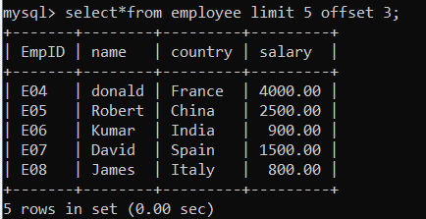

### ORDER BY

SELECT * FROM employee ORDER BY empid ASC;

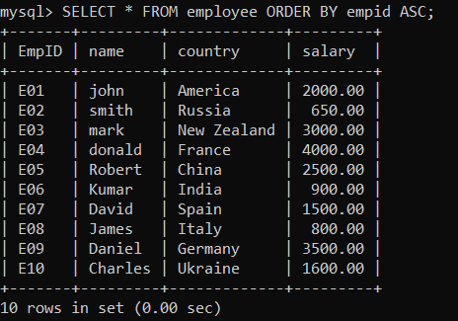

SELECT * FROM employee ORDER BY empid DESC;

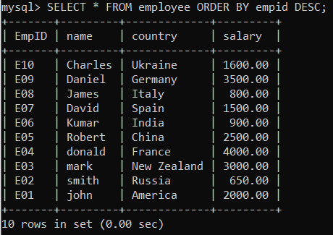

## === *UPDATE ===*

UPDATE employee SET name = 'kasun' , country = 'SL' WHERE empid = 'E01';

## === *DELETE ===*

DELETE FROM employee WHERE empid = 'e01';

## Primary key & Foreign key

CREATE TABLE order (

orderID VARCHAR (45),

cost DECIMAL(10,2),

cID VARCHAR (45) UNIQUE, 🡨 duplicate karanna ba

CONSTRAINT PRIMARY KEY (orderID),

CONSTRAINT FOREIGN KEY (cID) REFERENCES customer (cID)

);